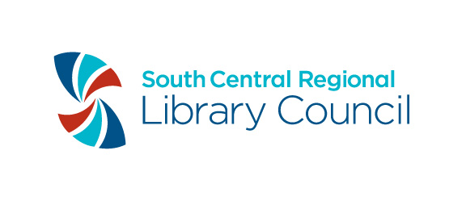
Digital Project Plan Outline

Project Title:______________________________________________________________

Project Manager:

Name_______________________________________________________________________

Phone______________________Email____________________________________________

Project start date ________________ Project end date __________________

Project Goals and Outcomes:
List the goals and desired outcomes of the project. What is the purpose of your project? What is the expected result at the end of your project?

Item type and estimated number of items to be digitized:

Photographs (B&W)
Photographs (Color)
Postcards
Handwritten materials such as manuscripts, scrapbooks or letters (indicate total number of items and estimated pages)
Printed or typed materials (indicate total number of items and estimated pages)
Newspapers
Audio
Video
Maps
Objects (3D)
Other (please describe)

Rights Assessment:
What is the rights status of the items you plan to digitize? Is the item in copyright? Do you need to do research/contact rightsholders before digitization?

Timetable (include interim and final reports in timetable)
List the tasks involved in your project and when you expect them to begin and end. Timetable must include materials selection, item description, digital reformatting, and uploading of materials into NYH or NYSHN.

Project Contributors & Roles:
List all contributors to this project, including your staff, vendors, SCRLC staff, and their roles. Who will be working on this project, and what will they do?

Contributor | Role

Equipment needed for project:
List all equipment needed to achieve project goals and outcomes. This may include hardware, software, and storage for digital objects.

Promotion methods:
How do you plan to promote your grant project once digitization and uploading has been completed?

